**Healthcare Price Dispersion in USA**

Group members: Ben Lamkin, David Johnson, Kabao Xiong and Renata Sant’Anna

**Data Summary:**

API route

url: <https://data.cms.gov/resource/tcsp-6e99.json?$limit=200000>

*Data – collection and preparation:*

Public dataset is provided by the CMS - Centers for Medicare & Medicaid Services, a federal agency within the [United States Department of Health and Human Services](https://en.wikipedia.org/wiki/United_States_Department_of_Health_and_Human_Services) (HHS), using the provider utilization and payment data Inpatient Public Use File (Inpatient PUF)

*Data information*:

Services and procedures provided to Medicare beneficiaries by hospital facilities. The Inpatient PUF contains hospital-specific charges for the more than 3,000 U.S. hospitals that receive Medicare Inpatient Prospective Payment System (IPPS) payments paid under Medicare based on a rate per discharge using the Medicare Severity Diagnosis Related Group (MS-DRG)

Date: fiscal years 2011 through 2017 and reflect 100% final-action (all claims resolved)

Total observations: 196,325 payments

Last update: August 28, 2019

**Fields used on our analysis:**

* DRG Definition: diagnosis-related group. Groups with similar clinical conditions (diagnoses) and the procedures furnished by the hospital during the stay.
* Provider ID: CMS Certification Number (CCN) assigned to the Medicare-certified hospital facility.
* Provider Name: name of the provider
* Provider City: the city where the provider is located
* Provider State: the state where the provider is located.
* Provider Zip Code: the provider’s zip code
* Hospital Referral Region Description: the Hospital Referral Region (HRR) where the provider is located.
* Total Discharges: the number of discharges billed by the provider for inpatient hospital services.
* Average Covered Charges: the provider's average charge for services covered by Medicare for all discharges in the DRG
* Average Medicare Payments: the average amount that Medicare pays to the provider for Medicare's share of the MS-DRG.

**Entire dataset summary**

|  | **Unique DRGs** | **Unique Providers** | **Unique Provider States** | **Unique Provider Zip Codes** | **Unique Regions** | **Total Discharge Count** | **Average Charge** | **Max Charge** | **Min Charge** |
| --- | --- | --- | --- | --- | --- | --- | --- | --- | --- |
|  | 563 | 3,182 | 51 | 2,899 | 306 | 7,382,688 | $61,166.15 | $3,325,523.35 | $2,644.78 |

Comments: On the entire dataset, we have almost 600 unique diagnosis, from more than 3,000 providers (hospitals), across all 51 states in the USA. From the discharge count, which means visits to the hospitals, we can see that there are more than 7M of these, and the average charged price across the entire dataset is around $61k.

**Entire dataset for the Tennessee region**

|  | **Unique DRGs** | **Unique Providers** | **Unique Provider Zip Codes** | **Unique Regions** | **Total Discharge Count** | **Average Charge** | **Max Charge** | **Min Charge** |
| --- | --- | --- | --- | --- | --- | --- | --- | --- |
|  | 367 | 88 | 84 | 8 | 194,421 | $54,852.10 | $1,156,043.00 | $5,628.88 |

**Entire dataset for Nashville - TN**

|  | **Unique DRGs** | **Unique Providers** | **Unique Provider Zip Codes** | **Total Discharge Count** | **Average Charge** | **Max Charge** | **Min Charge** |
| --- | --- | --- | --- | --- | --- | --- | --- |
|  | 308 | 41 | 40 | 77,706 | $54,810.48 | $963,475.81 | $5,6628.88 |

Comments: For the TN dataset, we have 88 unique providers for 367 different types of diagnosis/ procedure in 8 unique regions in TN (like: Memphis, Knoxville, Nashville and so on).

Total number of hospital visits is 194,421 and the average price charged for a diagnosis based on the TN dataset is around $54k.

Nashville has almost half of the number of the providers (hospitals) in whole TN, across different zip codes. Total number of hospital visits in Nashville is about 77k and the average price charged by hospitals are almost the same of the TN region: around $54k.

DRGs: Diagnosis we will analyze:

1. Heart Failure (Aggregate condition)
2. Drug Poisoning (Aggregate condition)
3. Alcohol/ Drug Abuse or dependence (Aggregate condition)

Comments: Among 563 different diagnosis/ procedures, we decide to analyze the conditions above.

Heart Failure condition has one of the highest number of hospital visits, so that is the reason why we want to investigate the price dispersion.

Drug Poisoning and Alcohol/ Drug abuse or dependence we find it interesting to see it from a Nashville and TN perspective.

1. **Heart Failure**

**The entire dataset filtering by DRG – Heart Failure**

| **Unique Providers** | **Unique Provider Zip Codes** | **Total Discharge Count** | **Average Charge** | **Max Charge** | **Min Charge** |
| --- | --- | --- | --- | --- | --- |
| 2742 | 2571 | 359,442 | $39,896.30 | $175,171.47 | $6,391.57 |

**Average Charge for HEART FAILURE across US states**

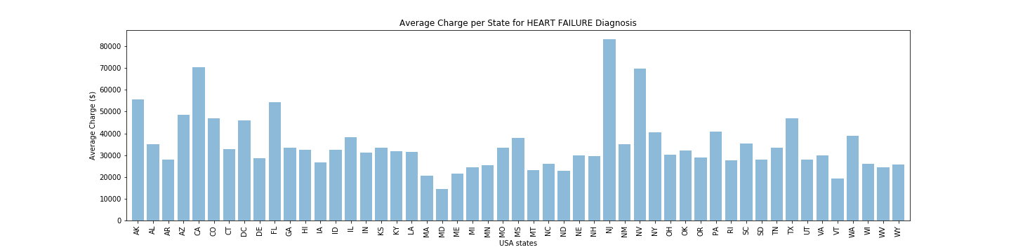

Comments: New Jersey (NJ), followed by California (CA) and Nevada (NV) are among the states that charged the highest amount for a heart failure diagnosis/ procedure, around $80,000.

On the other hand, Maryland (MD) and Vermont (VT) are among the states that charged the lowest price for a heart failure diagnosis/ procedure, less than $20,000.

**Heart Failure diagnosis data for the Tennessee region**

| **Unique Providers** | **Unique Provider Zip Codes** | **Total Discharge Count** | **Average Charge** | **Max Charge** | **Min Charge** |
| --- | --- | --- | --- | --- | --- |
| 77 | 75 | 8,953 | $33,385.69 | $62,063.59 | $12,259.79 |

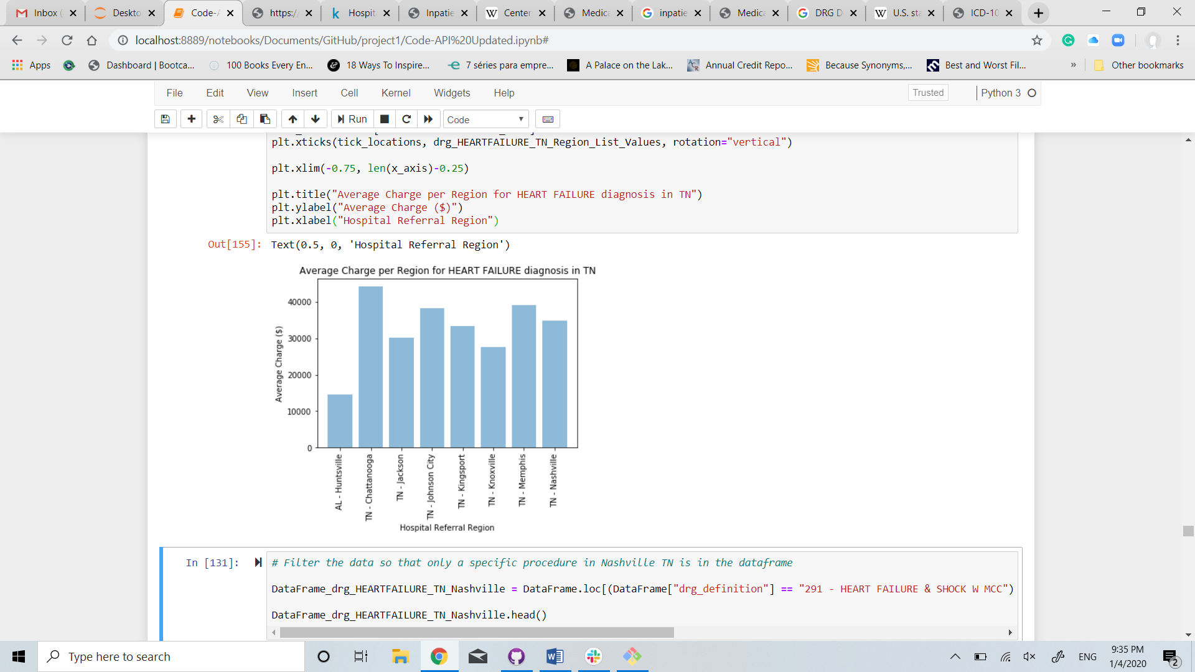

Comments: Given 77 different providers, located in 75 unique zip codes in TN region, Chattanooga and Memphis seems to have the higher prices charged for a Heart Failure diagnosis/ procedure, around $40,000.

Huntsville, AL is also on this database because, for cardiovascular diagnosis, is common to use the hospital referral region. Depending on how complicated the case is and the specialty needed, it is recommended to cross the state boarders for the best procedure. Huntsville, AL reports the lowest average charges, less than $15,000 followed by Knoxville, TN, of about $28,000.

**Heart Failure diagnosis data for Nashville - TN**

| **Unique Providers** | **Unique Provider Zip Codes** | **Total Discharge Count** | **Average Charge** | **Max Charge** | **Min Charge** |
| --- | --- | --- | --- | --- | --- |
| 31 | 31 | 3,105 | $34,770.52 | $62,063.59 | $12,259.79 |

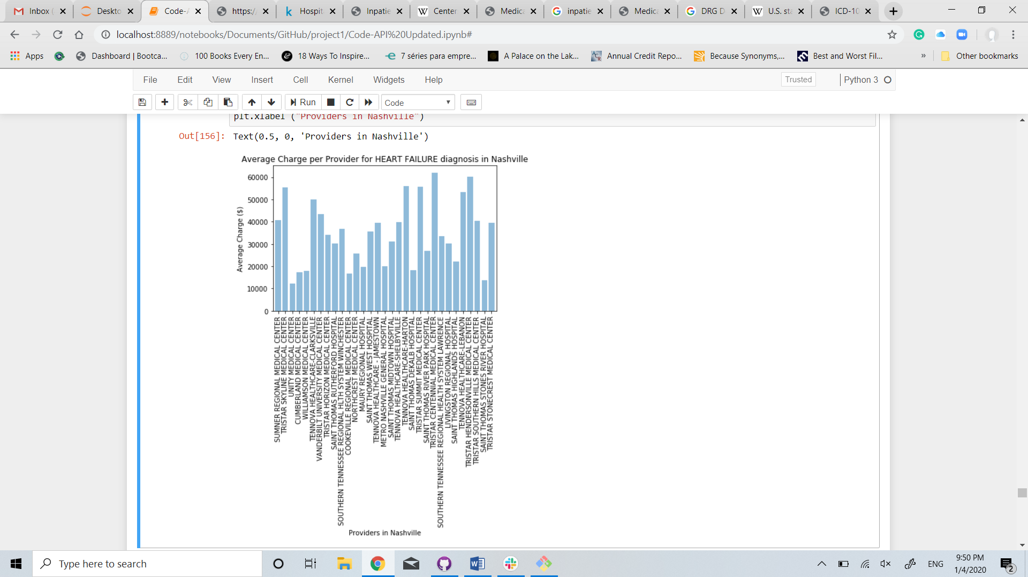

Comments: Analyzing 31 unique providers in Nashville (metropolitan area) in 31 unique zip codes, around 3,000 hospital visits, Tristar Centennial Medical Center charged the highest price among all others, about $60,000. On the other hand, Unity Medical Center charged a little more than $10,000.

Is there a correlation between the VOLUME OF HOSPITAL VISITS vs HOSPITAL AVERAGE CHARGED PRICES for HEART FAILURE diagnosis/ procedure?

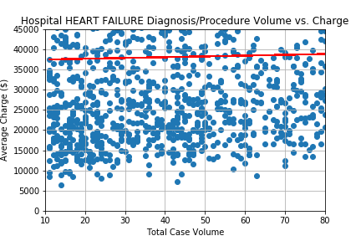

Correlation = 0.1050 (weak positive correlation)

Comments: The scatter plot above shows a really spread data and we can say that there is a weak positive correlation, of 0.1050, among volume hospital visits and average charged prices of the providers, meaning that the relationship is not too strong, even though they tend to move together to the same direction.

1. **Drug Poisoning**

**The entire dataset filtering by DRG – Drug Poisoning**

| **Unique Providers** | **Unique Provider Zip Codes** | **Total Discharge Count** | **Average Charge** | **Max Charge** | **Min Charge** |
| --- | --- | --- | --- | --- | --- |
| 671 | 649 | 12,021 | $26,007.14 | $79,734.10 | $5,482.94 |

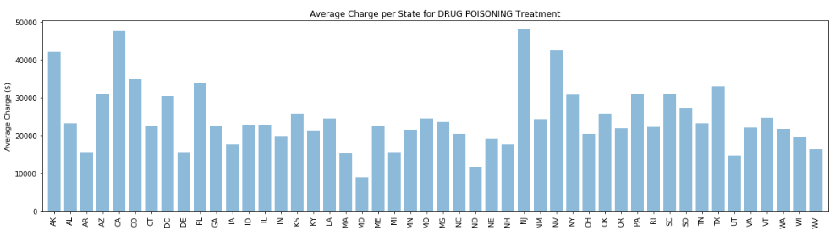

Comments: The average charge amount by state for Drug Poisoning Treatment varies significantly across the country ranging from about $9k to up to nearly $50k. Alaska, California, New Jersey and Nevada stick out as charging the most with having average charge amounts greater than $40k for Drug Poisoning Treatment. This compares to the Average of about $23k from Hospitals in TN. Maryland has the lowest average at about $9k.

**Drug Poisoning diagnosis data for the Tennessee region**

| **Unique Providers** | **Unique Provider Zip Codes** | **Total Discharge Count** | **Average Charge** | **Max Charge** | **Min Charge** |
| --- | --- | --- | --- | --- | --- |
| 19 | 19 | 294 | $23,216.76 | $39,630.85 | $9,758.00 |

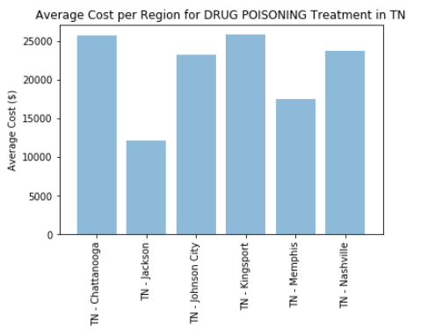

Comments: The bar chart above is looking specifically at the average charge of drug poisoning treatment by hospitals by Region in Tennessee. Even within the state there is a wide range of average charges with the lowest in Jackson at just over $10k and the highest in Chattanooga and Kingsport at about $26k. The average cost in Nashville is about $24k.

**Drug Poisoning diagnosis data for Nashville - TN**

| **Unique Providers** | **Unique Provider Zip Codes** | **Total Discharge Count** | **Average Charge** | **Max Charge** | **Min Charge** |
| --- | --- | --- | --- | --- | --- |
| 12 | 12 | 167 | $23,775.86 | $36,282.88 | $9,758.00 |

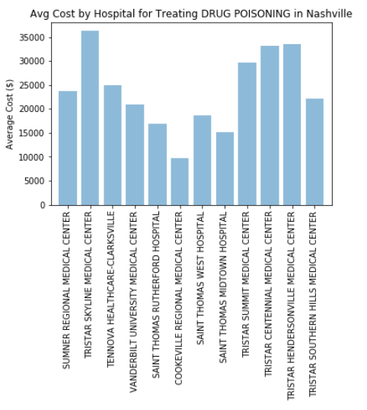

Comments: The bar chart above is looking specifically at the Average Charge of Drug Poisoning Treatment by Hospitals in Nashville. This shows that even within Nashville there is a wide range of Charges ranging from about $10k at Cookeville Regional Medical Center to over $35k at Tristar Skyline Medical Center Hospital.

Is there a correlation between the volume of hospital visits and charged prices by providers regarding Drug Poisoning treatment?

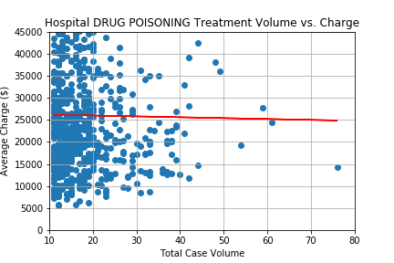

Correlation = -0.011 (weak negative correlation)

Comments: The above scatter plot with the linear regression shows the average charge amount for drug poisoning treatment among hospitals across the country along with the associated hospital’s average case volume for Drug Poisoning treatment. This indicates a **very** weak negative correlation, of -0.011 that hospitals with higher Drug Treatment volume charge less (*the dots start to get lower avg charges as Total Case Volume increases to the right*); however, for the most part it shows that for hospitals that have a relatively low volume there is a wide range of charges for Drug Poisoning treatment ranging from around $5k to up to $45k.

1. **Alcohol/ Drug abuse or dependence**

**The entire dataset filtering by DRG – ALCOHOL/DRUG ABUSE OR DEPENDENCE**

| **Unique Providers** | **Unique Provider Zip Codes** | **Total Discharge Count** | **Average Charge** | **Max Charge** | **Min Charge** |
| --- | --- | --- | --- | --- | --- |
| 849 | 813 | 28,695 | $25,714.06 | $107,262.79 | $3,572.08 |

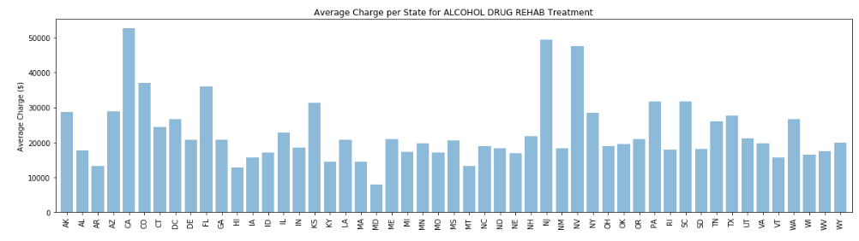

Comments: The bar chart above shows how the average charge amount by state for alcohol drug rehab treatment varies significantly across the country ranging from about $8k to up to nearly $53k. California, New Jersey and Nevada stick out as charging the most with having average Charge Amounts greater than $40k for Drug Poisoning Treatment. This compares to the Average of about $26k from Hospitals in TN. Maryland has the lowest average at about $8k.

**Alcohol/ Drug abuse or dependence diagnosis data for the Tennessee region**

| **Unique Providers** | **Unique Provider Zip Codes** | **Total Discharge Count** | **Average Charge** | **Max Charge** | **Min Charge** |
| --- | --- | --- | --- | --- | --- |
| 13 | 13 | 335 | $25,954.13 | $44,361.94 | $9,212.75 |

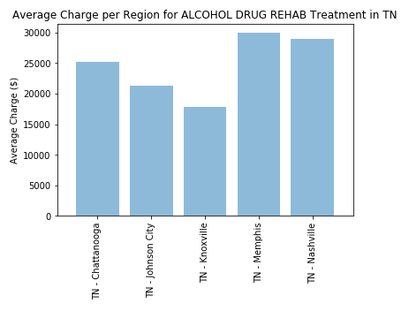

Comments: The bar chart above is looking specifically at the Average Charge of Alcohol Drug Rehab Treatment by Hospitals for the Regions within Tennessee. This shows that even within the state there is a wide range of average Charges with the lowest in Knoxville at about $18k and the highest in Memphis and Nashville at about $30k.

**Alcohol/ Drug abuse or dependence diagnosis data for Nashville - TN**

| **Unique Providers** | **Unique Provider Zip Codes** | **Total Discharge Count** | **Average Charge** | **Max Charge** | **Min Charge** |
| --- | --- | --- | --- | --- | --- |
| 5 | 5 | 170 | $28,999.76 | $44,361.94 | $16,710.32 |

* 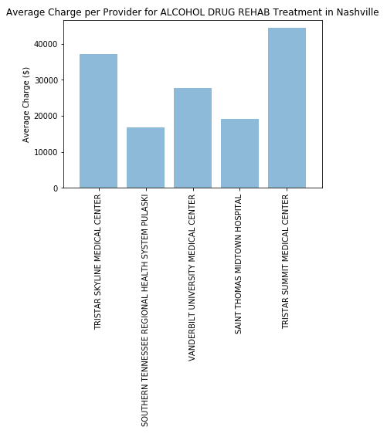

Comments: The bar chart above is looking specifically at the Average Charge of Alcohol/Drug Abuse or dependence diagnosis/ procedure by Hospitals in Nashville. This shows that even within Nashville there is a wide range of Charges ranging from about $17k at Southern Tennessee Regional Health System Pulaski to over $44k at Tristar Summit Medical Center.

Is there a correlation between the volume of hospital visits and charged prices by providers regarding the Alcohol/ Drug abuse or dependence treatment?

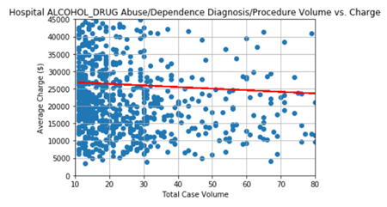

Correlation = -0.01666 (very weak negative correlation)